HUMBLE SIGN
PROCURE TO PAY
PROCESS FLOW DOCUMENT

Role: Purchasing Manager
Creating Vendor Records:
Navigation: Receiving -> Lists -> Vendors -> New
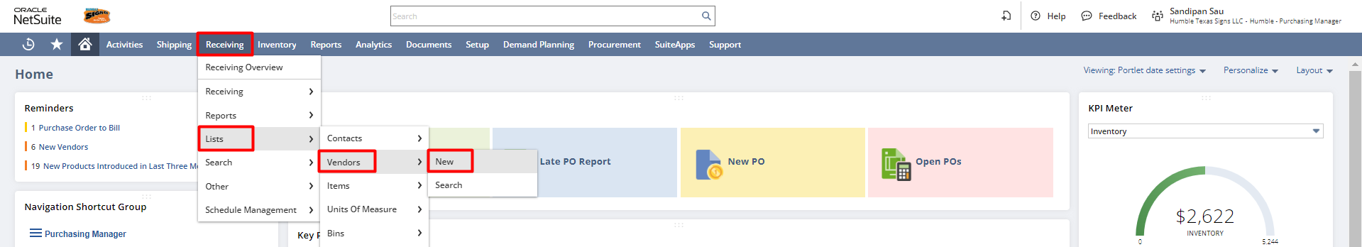

Step 1: Enter primary details like Type, Company Name, and Subsidiary if multiple subsidiaries are present. Users can also specify the phone number, web address, and fax for a vendor.
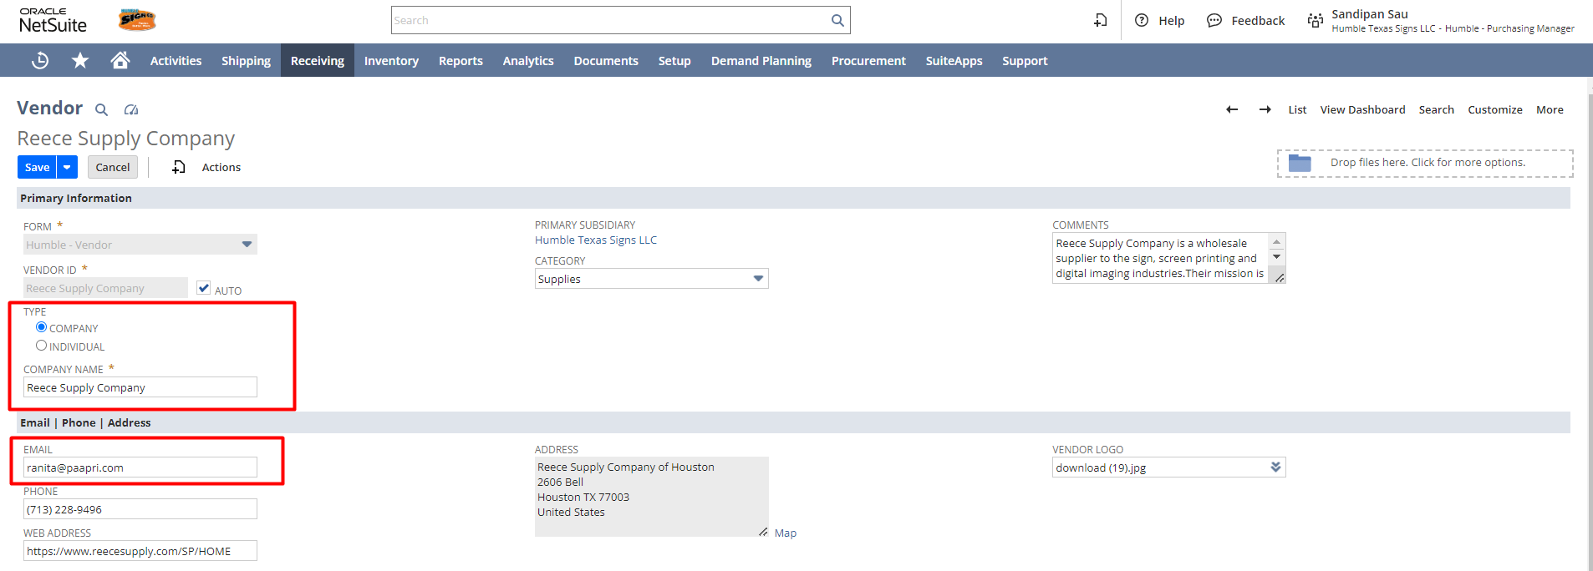
Step 2: Enter Financial details like Terms, Credit Limit, Primary Currency, Legal Name and other required information if required. Although NetSuite fetches the company name in the Legal Name field by default, it can be changed by editing the field.
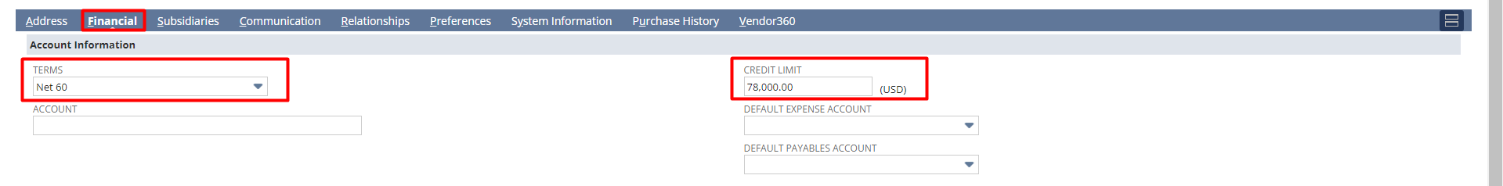Step 3: Enter Address Details. To add an address, click the Edit button with a pencil icon. If that vendor has a Default Shipping/Billing address, then check the Default Shipping/Billing checkboxes.
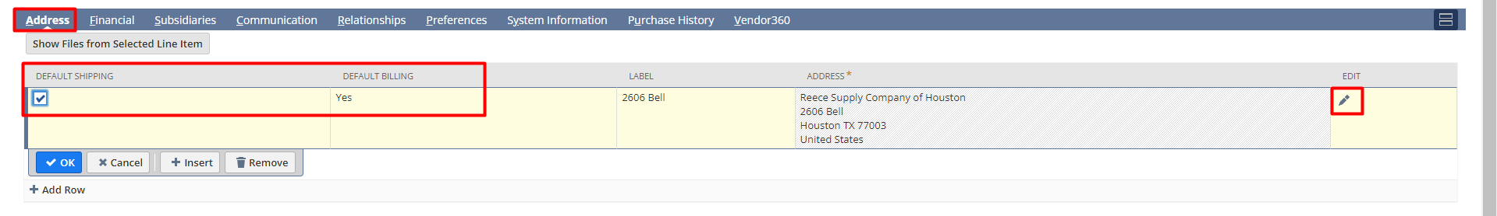
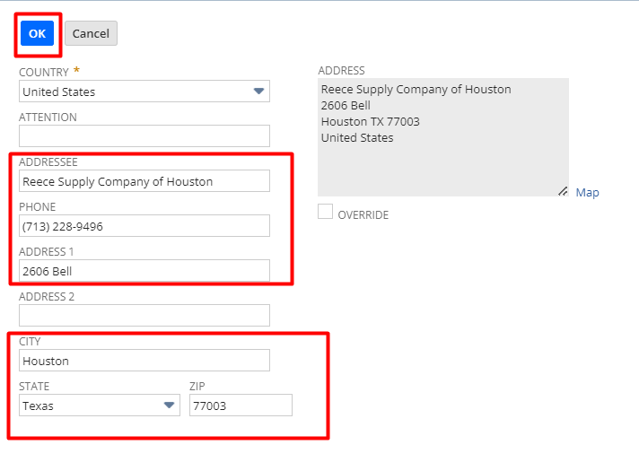
After clicking the Edit button, a page will open as shown below, enter the necessary details and click OK.

Step 3: Click on OK. Then, click the Save button from the vendor record.
Also to access the vendor record list navigate to Receiving -> Lists -> Vendors
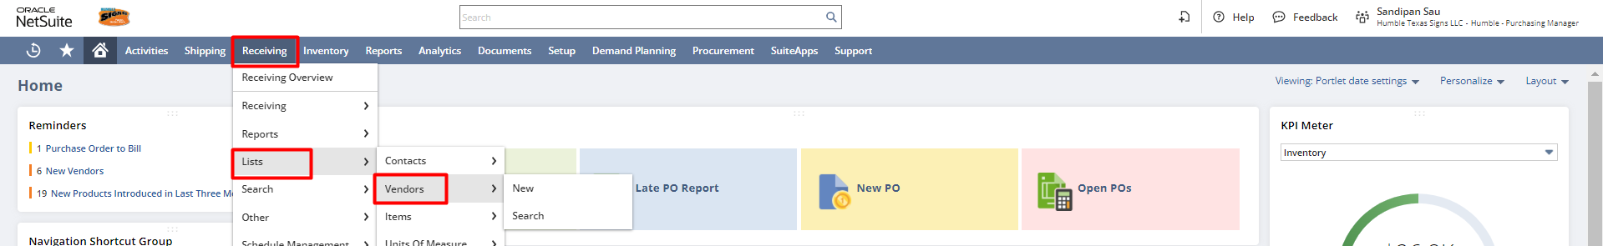
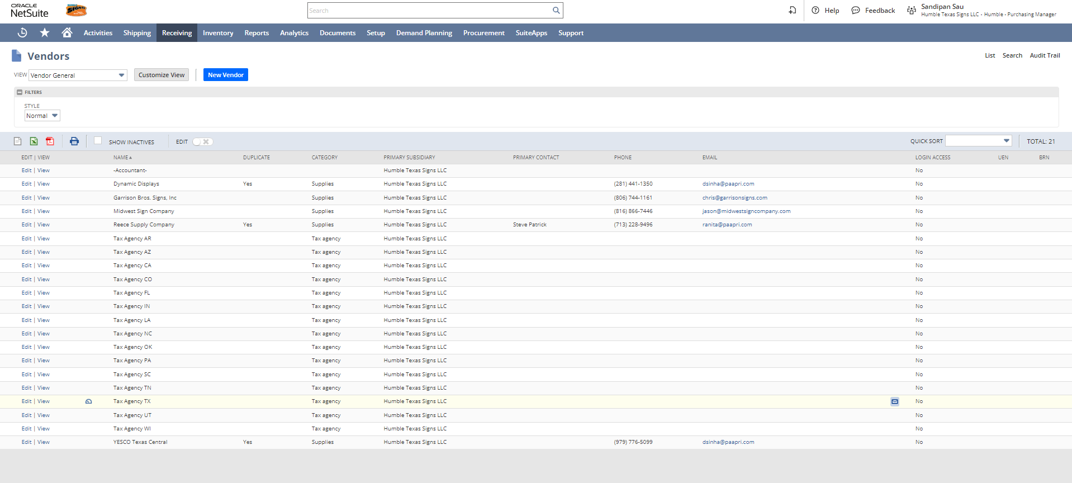
Creating Purchase Orders:
Navigation: Receiving -> Receiving -> Enter Purchase Orders
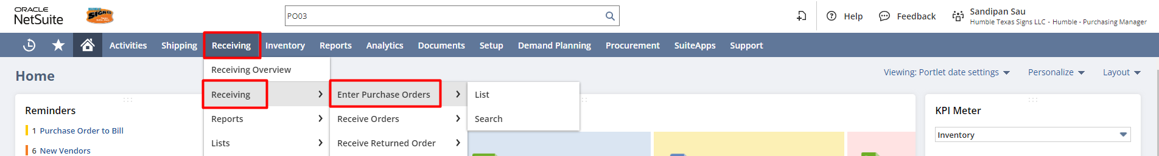
Step 1: Enter the required details for the Purchase Order like Vendor and Location. Under the Items subtab, select an Item from the Item dropdown and enter the Quantity and Rate and the amount will get auto-calculated based on the quantity and rate. Click the “Add” button to add multiple Items. Click the “Save” button.
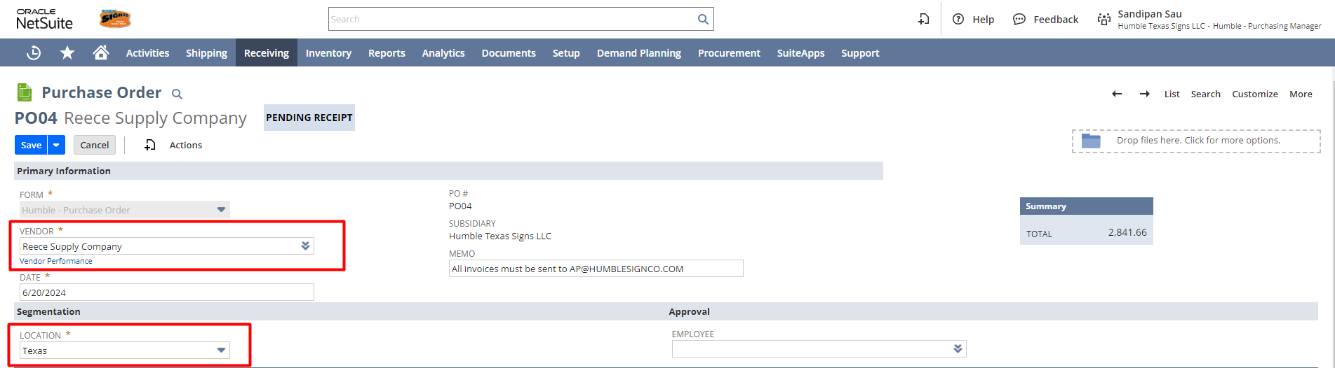

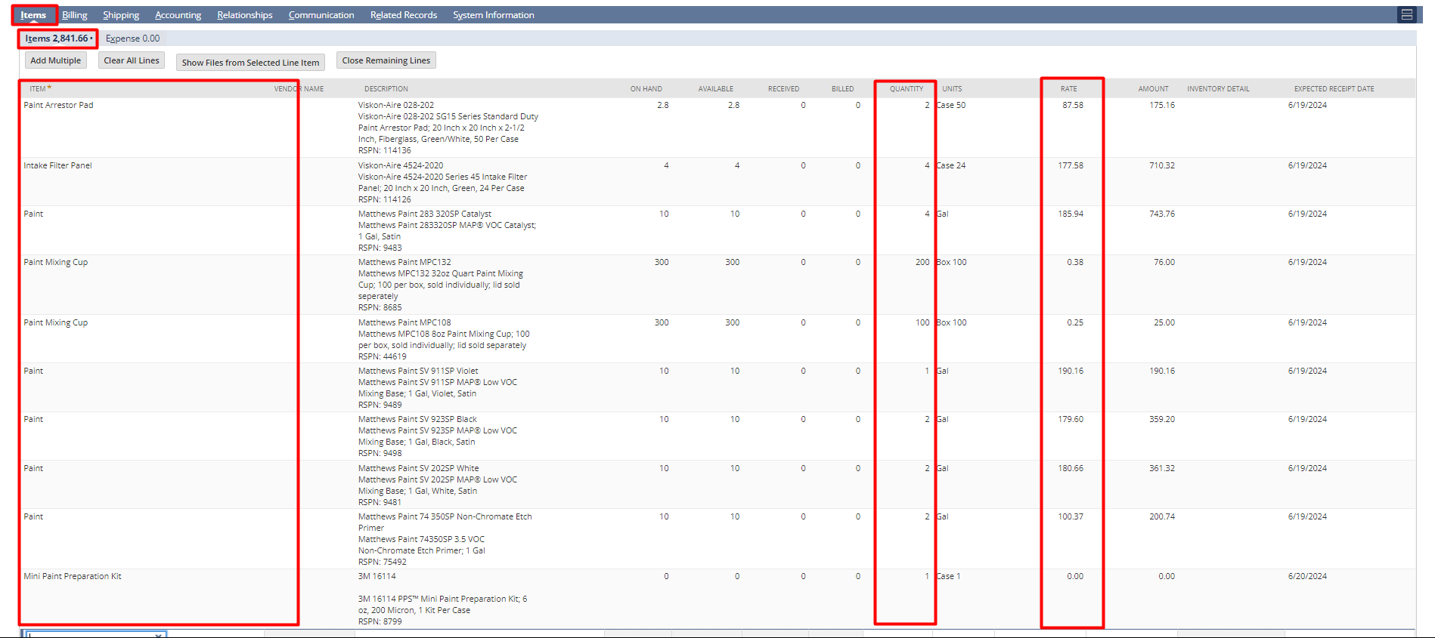
Step 2: Under the Shipping subtab select the Ship To, Shipping Method and Ship To Select.
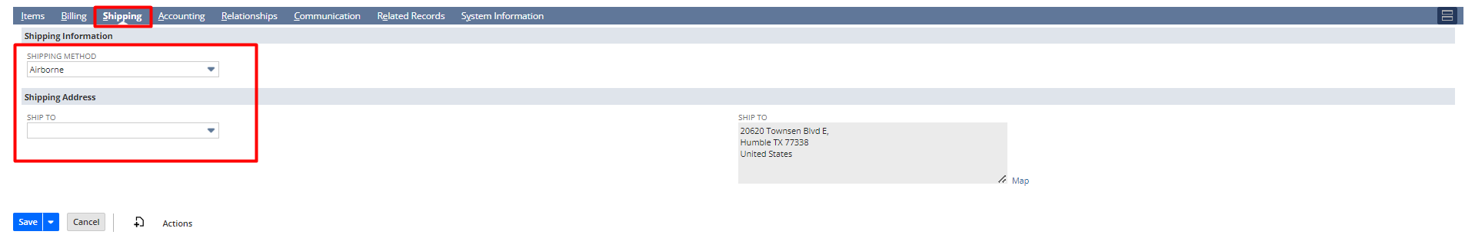

Step 3: Under the Billing subtab select the Vendor Select.
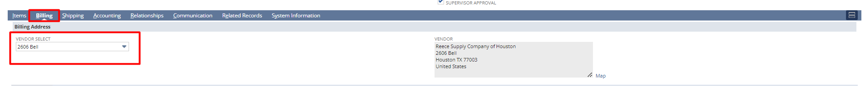

Step 3: Click on Print to print the Purchase order PDF.
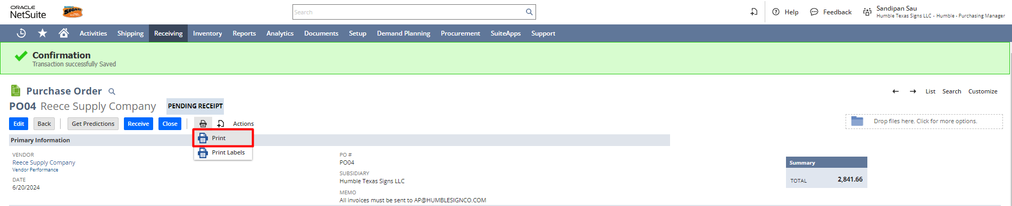
This is the preview of the Purchase Order PDF.
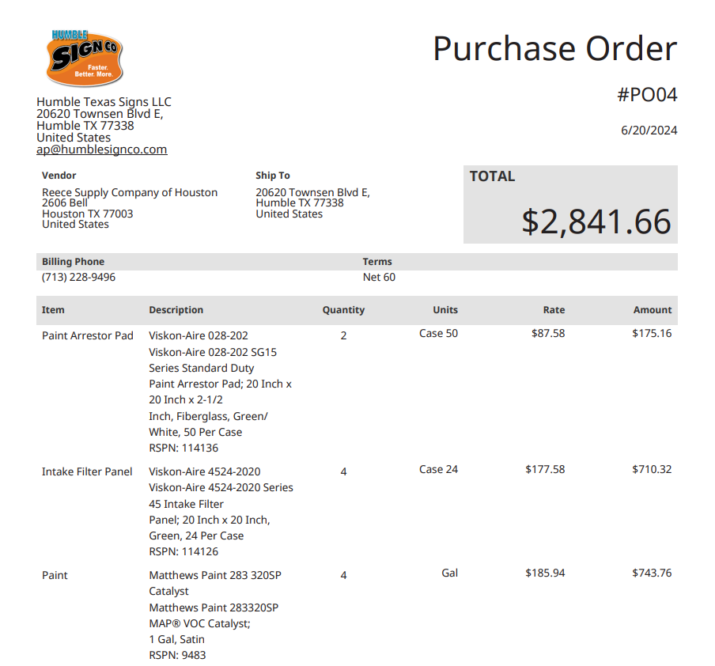
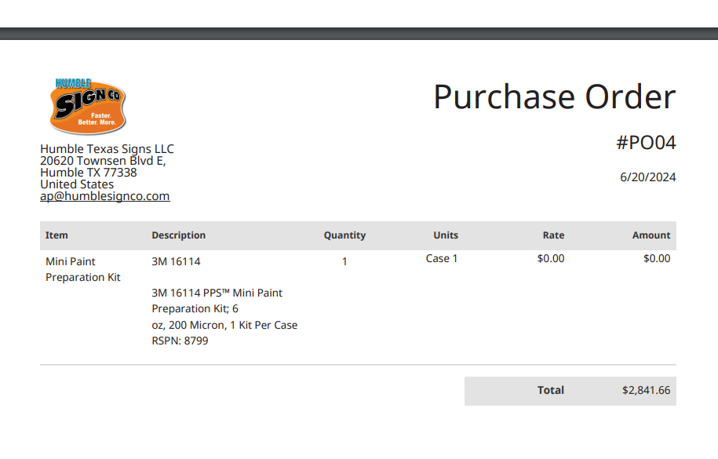

Role: A/P Analyst
Vendor Prepayments:
Navigation: Vendors -> Accounts Payable -> Enter Vendor Prepayment
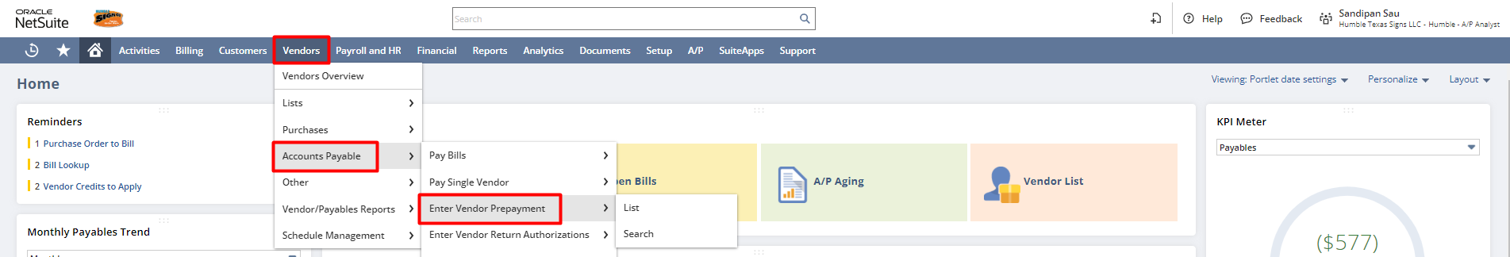
Step 1: Select the Payee, Purchase Order, Account and enter the Payment Amount you want to prepay. Click Save.
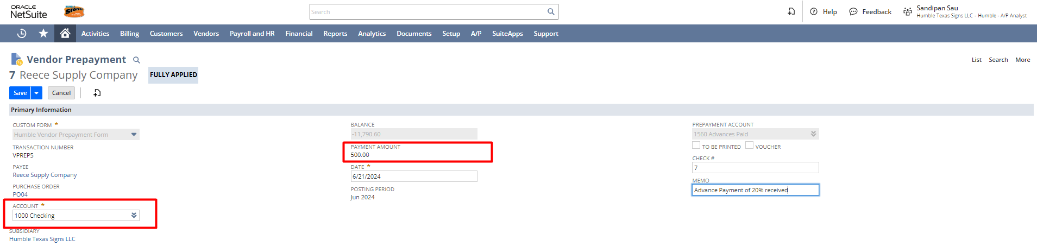
OR
You can directly enter the Vendor Prepayment from the Purchase Order as well
Navigation: Vendors -> Purchases -> Enter Purchase Orders -> List
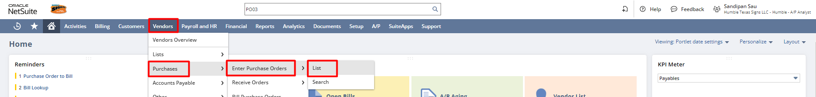
Step 1: Select the corresponding Purchase Order and click on View to open the Purchase Order
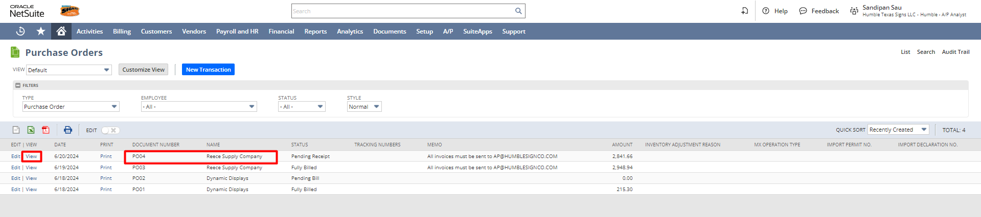
Step 2: Click on the Enter Prepayment button to enter a Vendor Prepayment record.
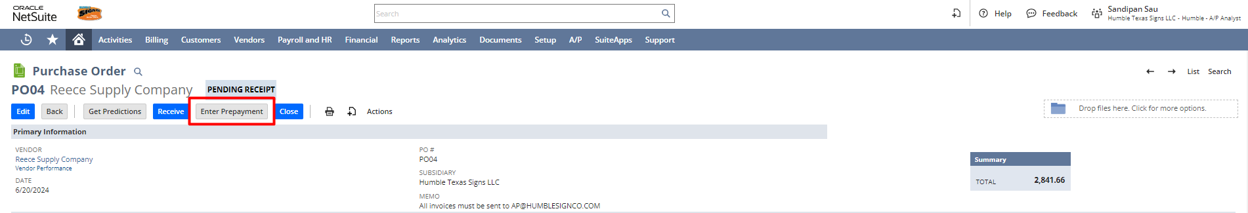
Step 3: Click on the Enter Prepayment button to enter a Vendor Prepayment record. Enter the Account and Payment Amount you want to prepay. Click Save.

Step 4: After saving click on Print to print the Vendor Prepayment PDF.
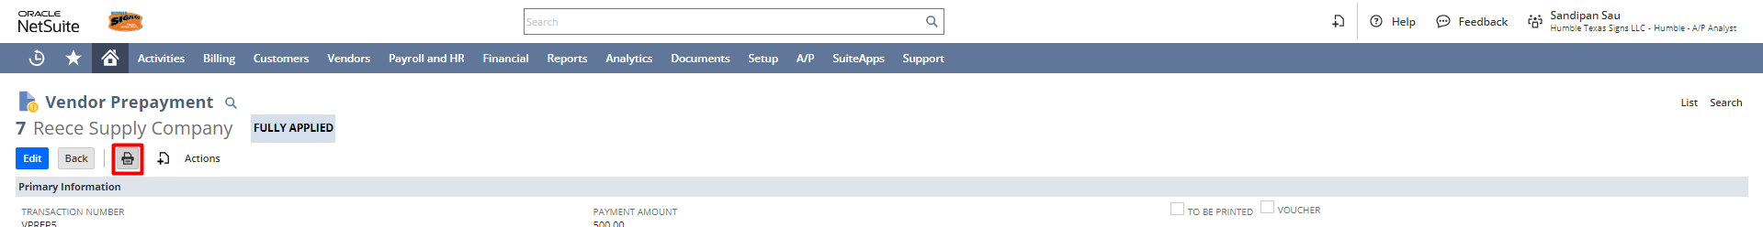
This is the preview of the Vendor Prepayment PDF.
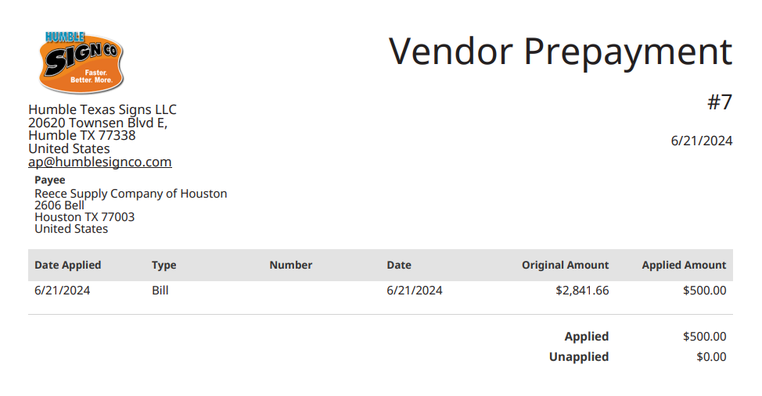
Role: Warehouse Manager
Receiving Purchase Orders:
Navigation: Click on Orders to Receive
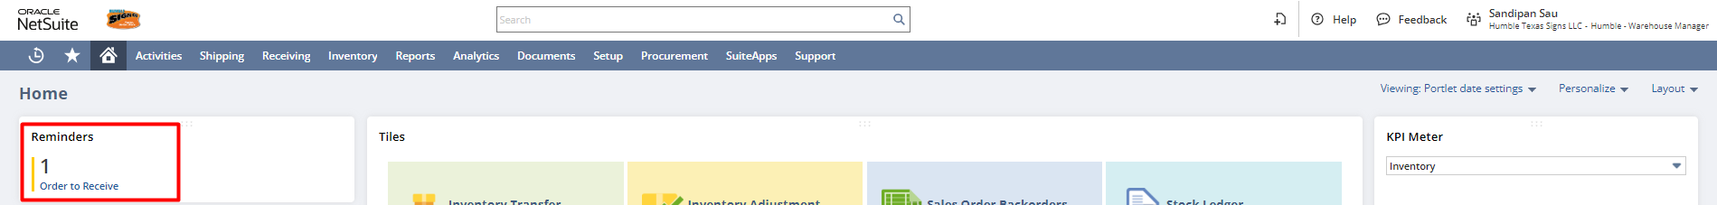
Or
Navigation: Receiving -> Receiving -> Receive Orders
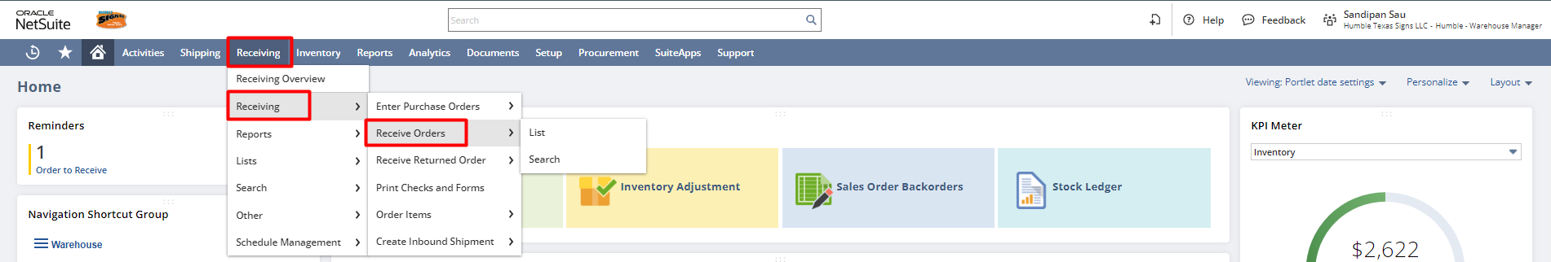
Using both the navigation you will land on the Receive Orders page. Click on the Receive or Date hyperlink to receive the purchase order.
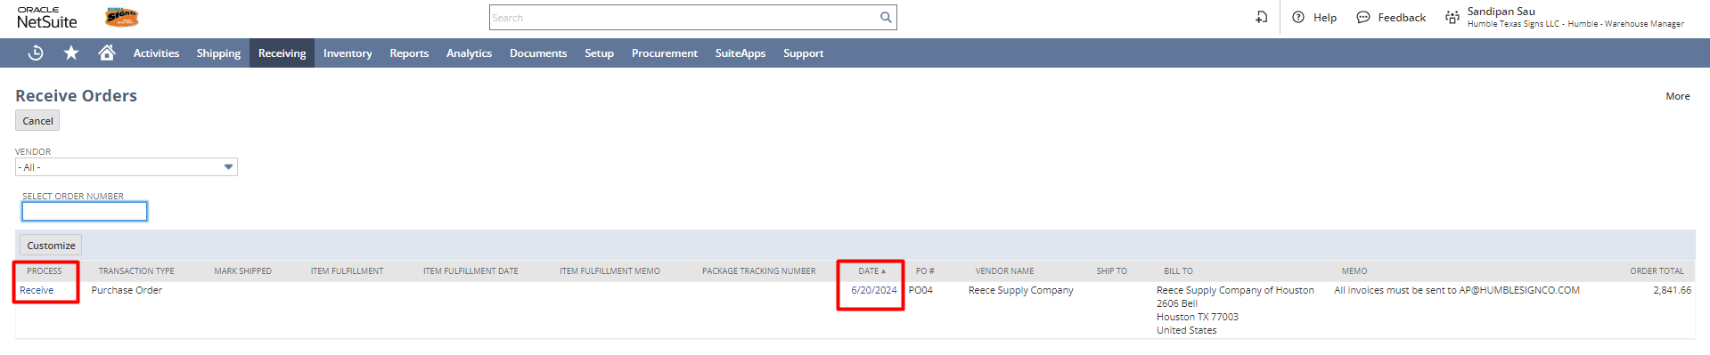
Step 2: In the Item Receipt record, under the Items & Expenses subtab, toggle the Quantity and Location if needed and always check whether the receive checkbox is checked for each/multiple items. Most of the details in this record will be automatically sourced from the Purchase Order record (For example: Vendor, Location, Items, Memo, etc.
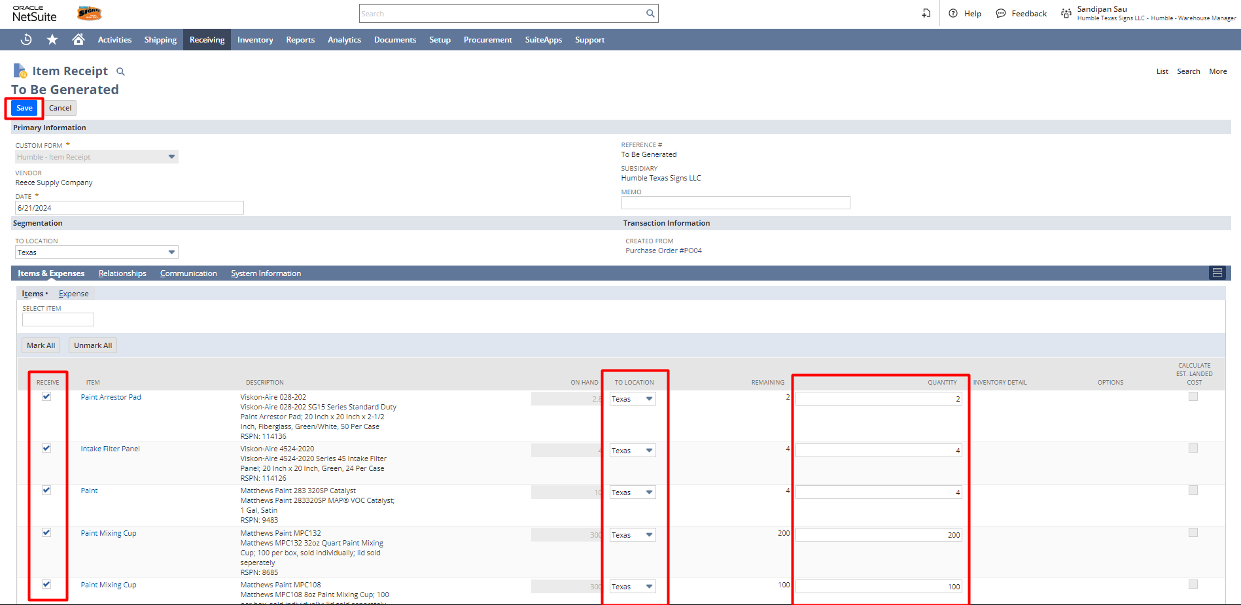

Step 3: After providing all details click on Save to save the Item Receipt record.
After receiving the items, we need to create a bill for the purchased products.
Role: A/P Analyst
Bill & Bill Payments:
Navigation: Vendors -> Purchases -> Bill Purchase Orders
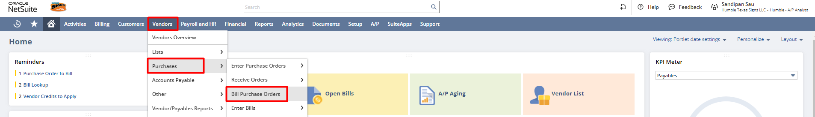
Step 1: Check the Checkbox and click Submit.
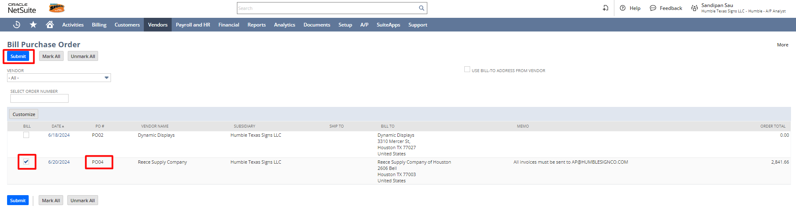
After submitting, a Bill page will open.
Step 2: Enter the Reference Number if present and click Save. Most of the information will be sourced from the Purchase Order itself, but users always have the option to configure any editable details on the fly.
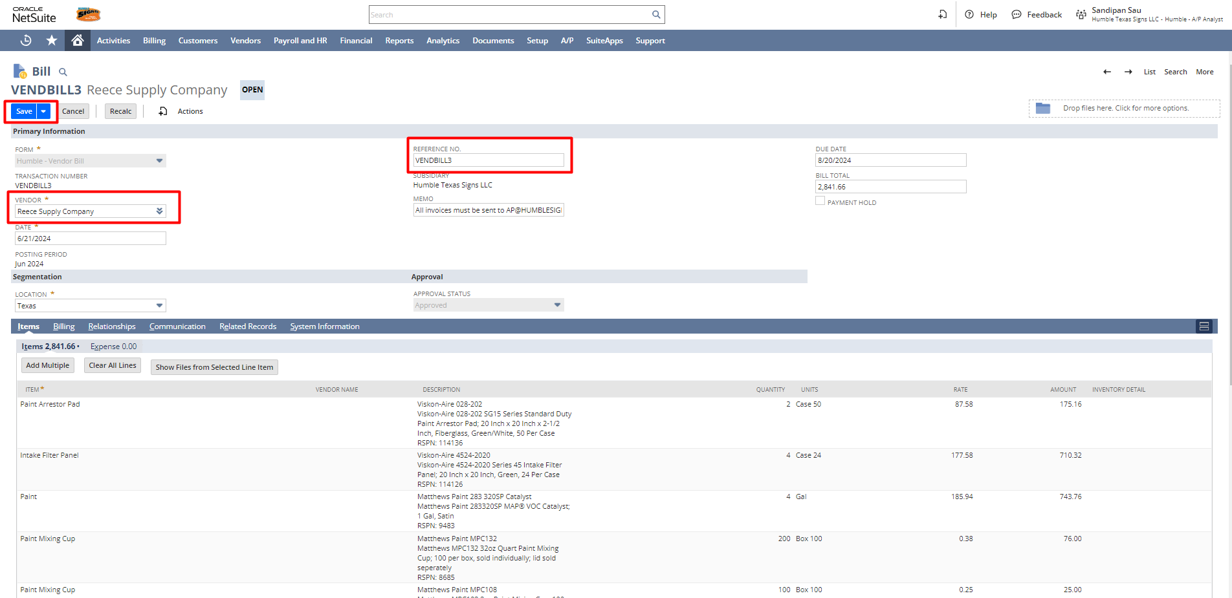
Navigate to the saved bill for bill payment. To do that navigate to Vendors -> Purchases -> Enter Bills -> List.
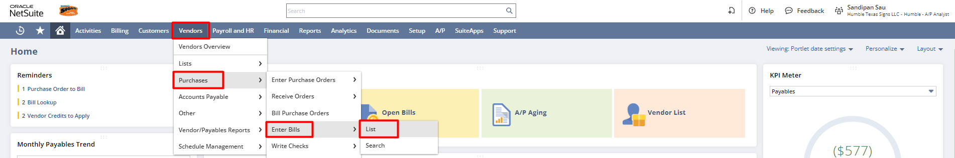
Step 3: Bill Payment. After navigating to the bill, click on the Make Payment button.
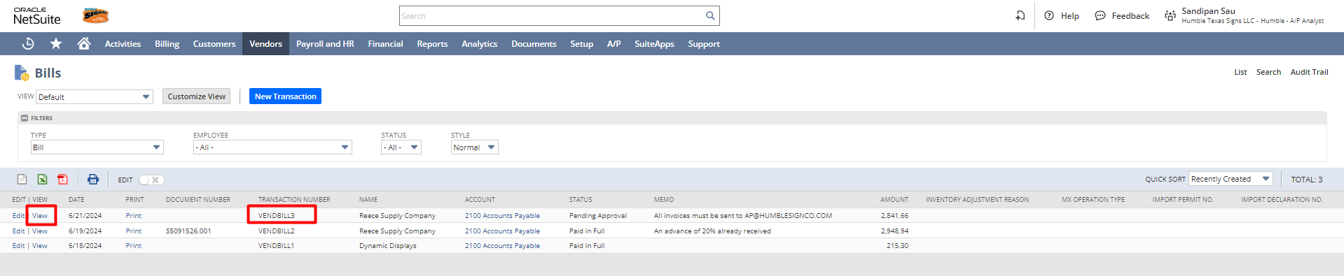
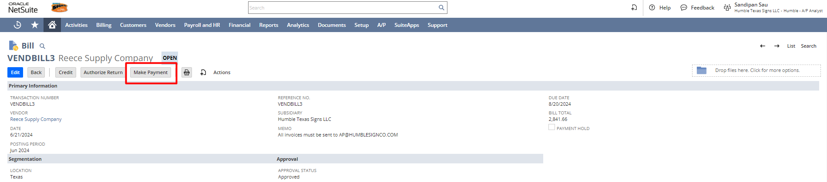
On the bill payment page, review the details that were populated from the bill. Make sure the checkbox beside the current bill should be checked or if multiple bills are to be paid at once then check the checkboxes accordingly and click Save.
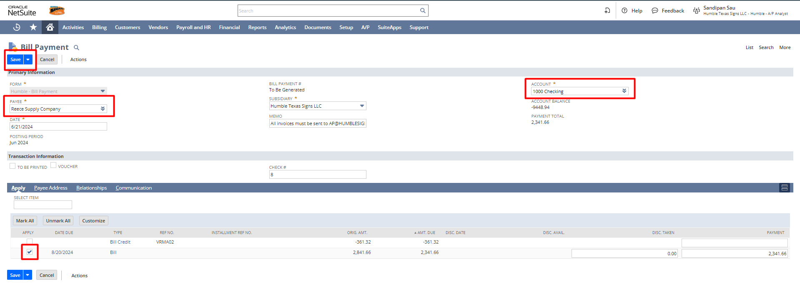
Step 4: After saving click on Print to print the Vendor Bill PDF.
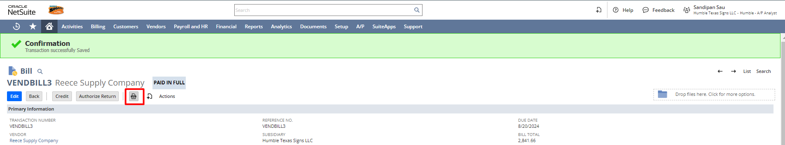
This is the preview of the Vendor Prepayment PDF.
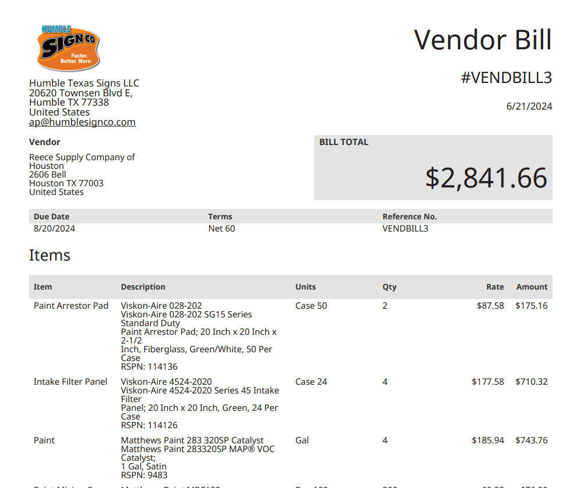
Role: A/P Analyst
Creating Stand Alone Bill & Bill Payments:
Navigation: Vendors -> Purchases -> Enter Bills
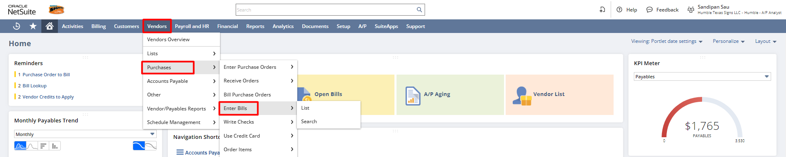
Enter the Vendor, Reference Number, and Location. Under the item subtab enter the Item, Quantity, and Rate. Click Save to save the bill.
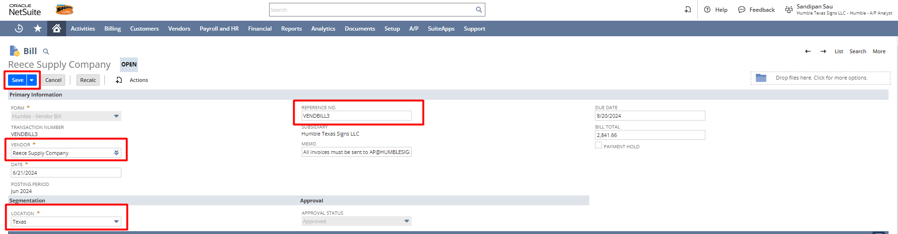
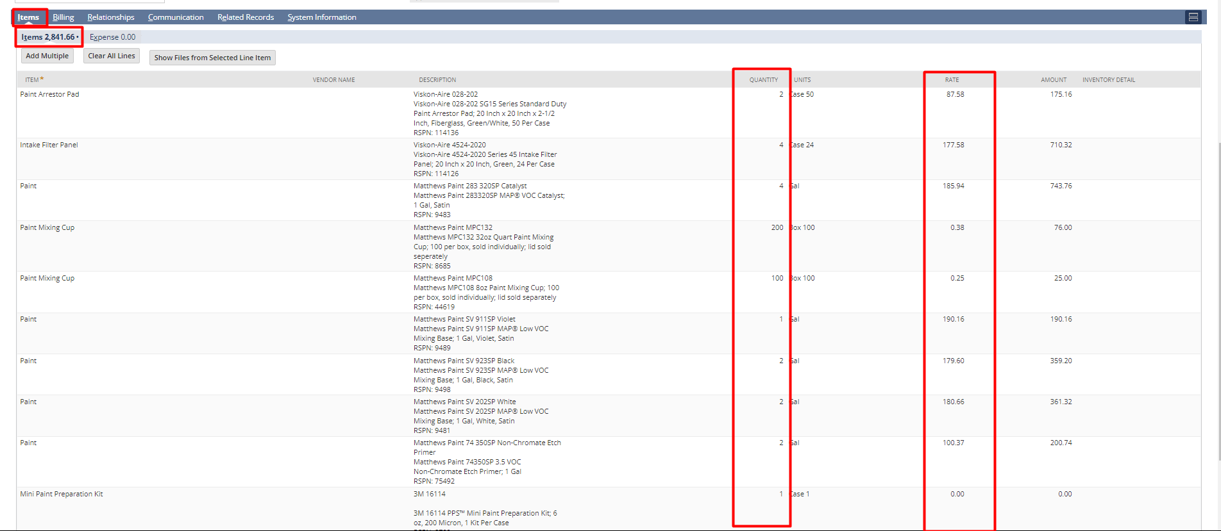
Click on the Make Payment button to make a payment against the bill.
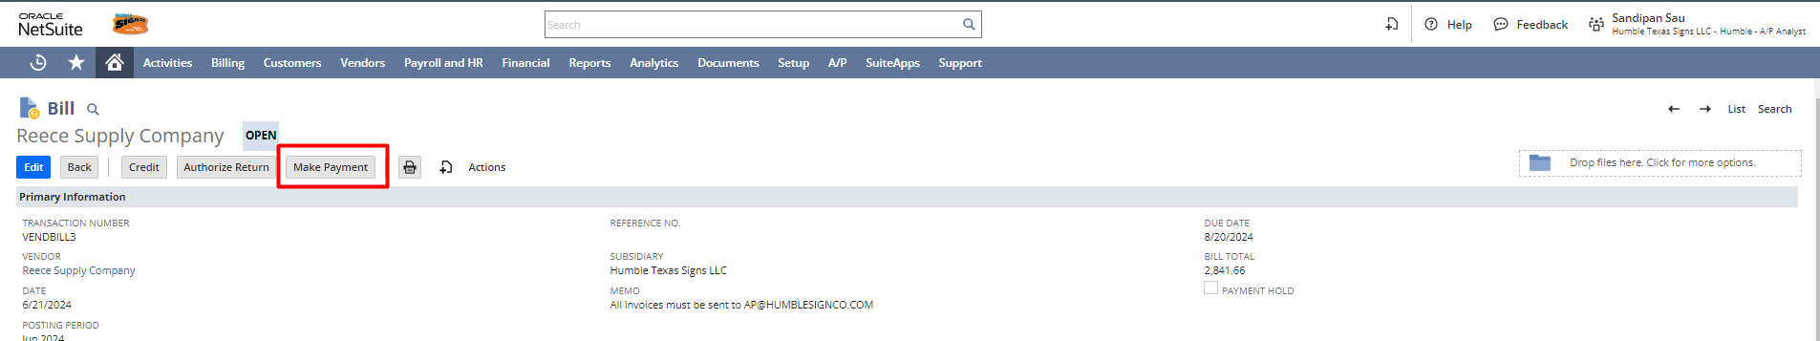
Click Save to save the bill payment.


Signature: ________________________________
Date: _____________________________________

Disclaimer:
Upon signing off on the process flow document, you are confirming that the process has been set up per the SOW within NetSuite per your business's needs. Any changes or modifications requested after sign-off will need to be a "change request" at an additional fee.

*** PLEASE ensure that you have logged into NetSuite and tested the process prior to signing off on the setup. Paapri requires sign-off on this document prior to moving forward with any additional design meetings.

